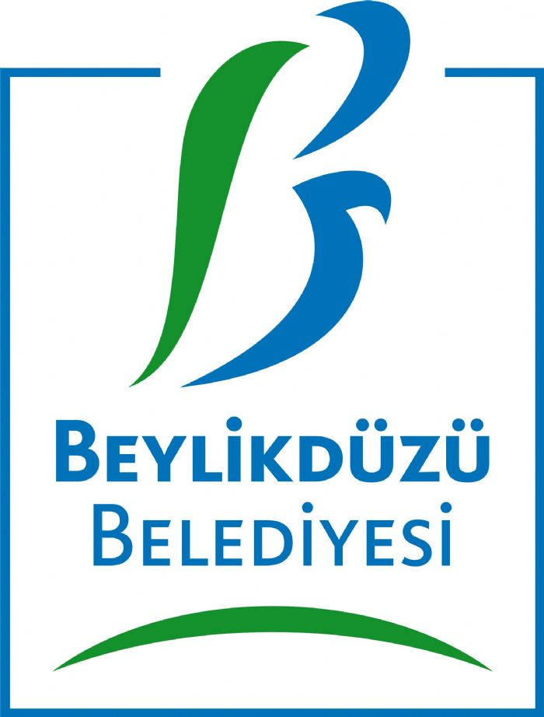Partner search from Beylikduzu

Programme: | LIFELONG LEARNING PROGRAMME – ERASMUS + GRUNDVİNG  (KA2 – Collabaration for innovation and Good Practice Exchange)
Deadline: | contact before 28 March 2014
Contact person: | Name: Safiye GENC  Title/profession: Project Manager  E-mail: safiye_genc@hotmail.com , safiyegenc@gmail.com  Address: Cumhuriyet Mah.Adnan Kahveci Cad. İstanbul , TURKEY
Organisation: | Beylikduzu municipality has a population of approximately 250.000 and the number of staff working within the municipality is around 400. Beylikduzu’s Employments department mission The Adult Sector works with education, sectors for Integration, Employment focuses on the labour market for the unemployed, career advice, etc.  Through legislation, Beylikduzu’s Employments department is obliged to help. This work is spread over the two sectors and attempts recruitment and placement.  Participants in this project are managers and other strategic staff within the Labour Market and Social Services department who are responsible for the strategic work concerning recruitment and placement. Some of the participants are also responsible for the competence development of staff and for developing new working methods.
Project idea: | In order to cope with the increased number and complexity of cases related to recruitment and placement, the department needs to develop new and creative strategies. Strategies which aim to improve and develop collaborations with NGOs and other authorities in the municipality who work with recruitment and placement and finding ways of recruitment and placement, staff of the trainer.  Beylikduzu Municipality is now looking for a European partner interested in participating in an already approved mobility project where one or two project manegers, would visit your organisation for a “job-shadowing” during 15 working days in 2014 (or early 2015).  The host organisation should be able to share good practice concerning partnership with NGOs (coordination, contracts and support for NGOs as well as different forums and strategies for this work), forums for collaboration between different authorities and strategies for preventative measures. Another example of good practice is how the host organisation manages work with a variety of recruitment and placement, staff of the trainer-groups, adults and disabled adults.  There is no funding available for the host organisation but there is of course a possibility for benchmarking and for visiting our organisationin the future. Hopefully further exchanges and collaborations can be planned between our organisations.  The main objective of the EU-funded project is for participants to acquire/develop:  - New methods of work with recruitment and placement and finding ways of recruitment and placement, staff of the trainer.  - New contacts/networks within the area of work  - Innovative creative solutions and ideas to improve work with recruitment and placement and finding ways of recruitment and placement, staff of the trainer  - Inspiration and knowledge on how to collaborate with other organisations, including NGOs and other authorities  - New knowledge when it comes to preventing recruitment and placement and finding ways of recruitment and placement, staff of the trainer, including awareness raising  - New knowledge when it comes to providing support to ALL groups affected by recruitment and placement and finding ways of recruitment and placement, staff of the trainer  - New knowledge on how to work with perpetrators  If you find this proposal interesting, please do not hesitate to make contact for further details at latest the 28 March 2014.
Partners searched: | A local authority responsible for working with recruitment and placement and finding ways of recruitment and placement, staff of the trainer and with a well established collaboration with NGOs. It is important that our partner has a good knowledge of the English language.
Key words: | Adults and adults with disabilities education in lifelong lerning.
Project period: | June 2014 – May 2016

